Why Are Symbols Important in Graphic Design?
Symbolism, or semiotics as it’s known in technical circles, plays such a large part in human communication because people are constantly looking for deeper meaning. Whether it’s in the stars, drawn on a cave wall or in the newest visual content, we add such meaning to our communication through the use and interpretation of signs.
Because we look for meaning in everything around us, anything can become a symbol as long as people interpret it to mean something other than its literal definition. Some symbols, however, have become so ingrained within our cultural sphere that they carry an almost universal meaning. After all, who doesn't immediately associate an owl with wisdom, a dove with peace or a red rose with romance?
Whether you're a designer, a filmmaker or a writer, all communicators must resort to symbolism to communicate a message. To help you create meaningful content that triggers the right associations in your audience, here are 40 symbols all storytellers should be familiar with.

20 Common Symbols and Meanings

1 Raven
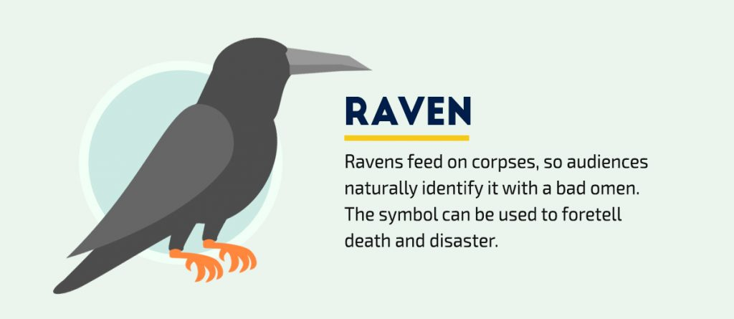
The narrative poem “The Raven” by Edgar Allen Poe is one of the most notorious examples of the use of this mysterious and macabre bird, which is often associated with its cousin, the crow.
As an animal that feeds on dead bodies, the raven has cemented itself as a sign of death and doom in the human psyche. The symbolism of ravens is so common that modern audiences identify it with a bad omen.
Visual communicators of all types can use the symbol to foreshadow death and disaster or create an atmosphere of doom and gloom.

2 Dove
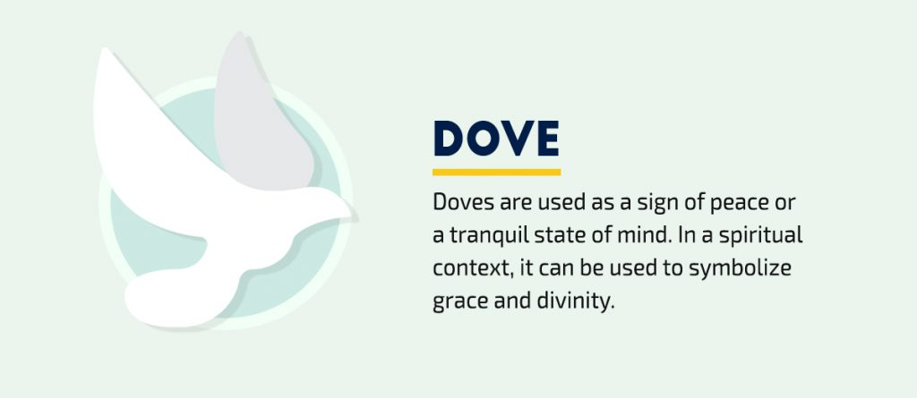
The dove is often associated with peace, tranquility and grace. Its meaning has become so universal that major world religions such as Christianity and Judaism have used the symbol as the truest representation of peace, grace and divinity.
In modern times, it has also become synonymous with pacifism and the end of a conflict. Its progression from a religious to a political symbol is evidenced in its adoption as the symbol of anti-violence campaigns and the Olympic games, which has become a means to promote international cooperation and peace.
Communicators of all types can use the symbol to communicate serenity, harmony, unity and the absence of violence.

3 Butterfly
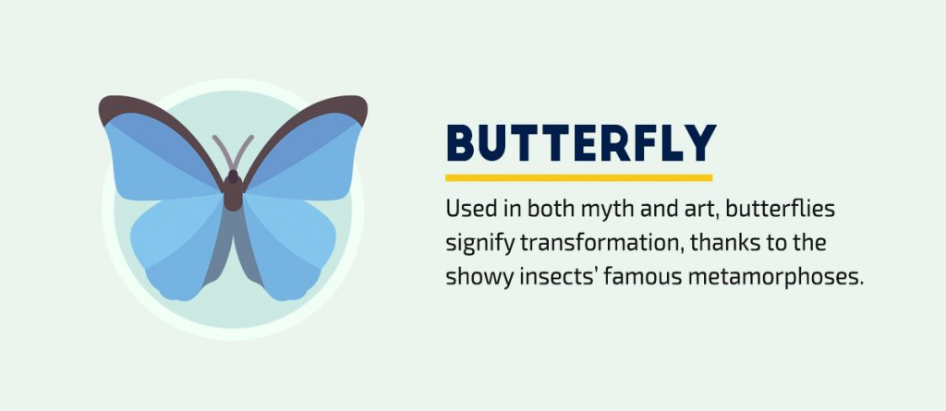
All over the world, in both myth and art, the butterfly is seen as a symbol of transformation and change, thanks to its metamorphosis from a wormy caterpillar to a stunning insect with vividly colored wings.
In certain cultures, this conspicuous insect is a representation of the soul and is used in tales and myths to signal a visit from someone who passed away or signal the possibility of life after death. For example, in the movie “Titanic,” the decorative butterflies on Rose’s hair comb were used to represent her freedom from the “cocoon” of her engagement to a man she did not love.
Communicators of all types can use this symbol to visually represent any type of change or transformation, both internal and external.

4 Cross
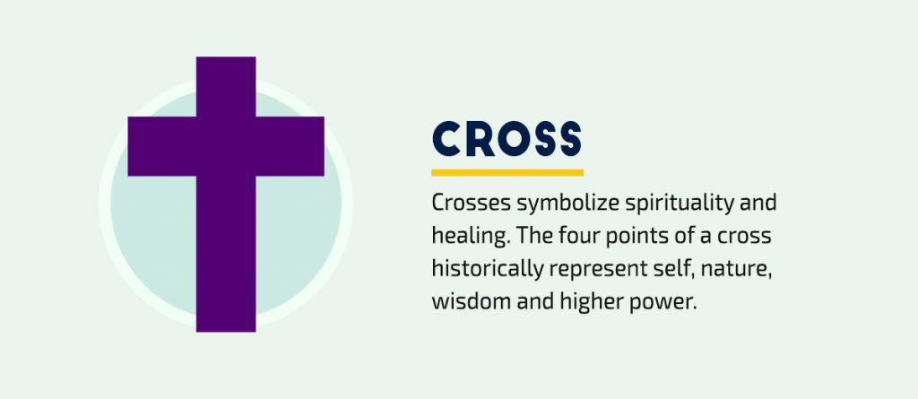
Across the globe, the cross is associated with Christianity, spirituality, forgiveness, resurrection and healing. More specifically, it represents Jesus’ victory over sin and death on the cross.
A red cross is commonly used as a symbol for medical and humanitarian relief workers in war zones and at the sites of natural disasters. It is also widely used to designate first aid and medical supplies, apart from its use by the International Red Cross, the American Red Cross and other organizations.

5 Water
Water historically represents life to a community since it’s a requirement for human survival. Thus, symbols for water were especially common throughout time, representing birth, fertility, and refreshment. In fact, water is often viewed as the source of life itself, as we see evidence in countless creation myths in which life emerges from primordial waters.
Just as we use water to wash away dirt, sweat and soil, water cleanses a canvas. But it also becomes a symbol of obstacles, such as a river or ocean to cross. Either way, water can be a symbol of power in visual stories, with the ability to claim audiences and characters, as well as free them.

Want to use symbols in your own visuals?
- Access over 6,000 vector icons
- Edit colors and adjust the size
- Use them in your presentations, printables, social graphics and any other type of visual content.

6 Owl
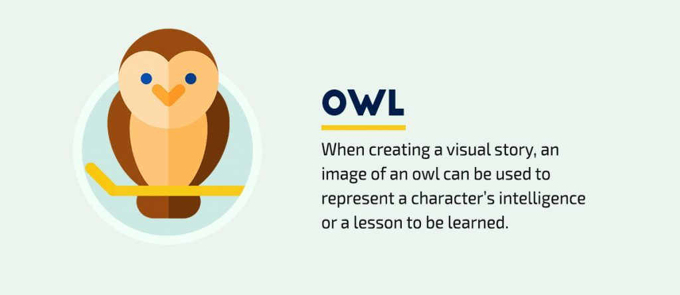
The use of the owl as a symbol is as popular today as it ever was: You see them everywhere, from accessories and clothing to interior design and home décor. But the symbol’s popularity is nothing new.
Its historical popularity as a symbol is also due to the fact that an owl always accompanied Athena, the Greek goddess of learning. In Native American cultures, the owl is seen as a creature of the night, and so is associated with the supernatural and even death.
Because they are usually nocturnal, owls have often been seen as mysterious and even magical creatures that dwell in and emerge from the darkness. Europeans in the Medieval Ages even believed the creatures might be sorcerers in disguise. Likewise, West African and Aboriginal Australian cultures viewed the owl as a messenger of secrets and a companion of sorcerers.
In a visual message such as a logo or design, an owl can be used to represent wisdom, intelligence or a lesson that needs to be learned.

7 Rose
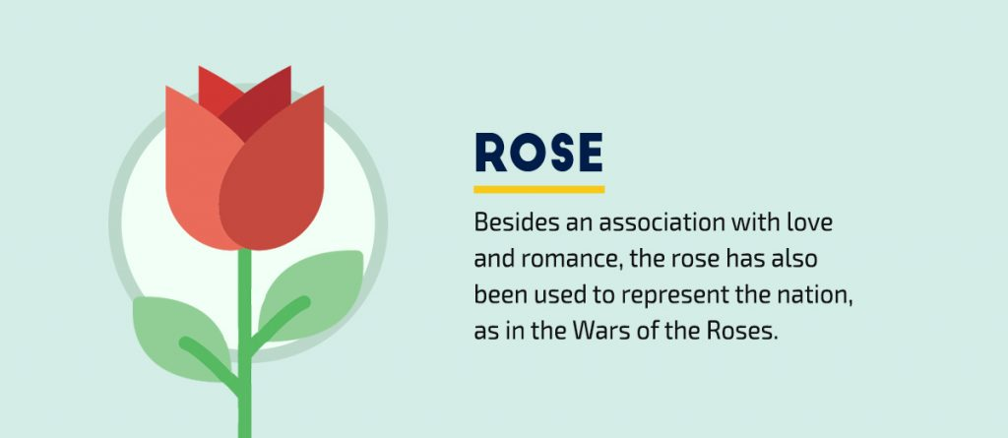
Who doesn’t associate a red rose with love and romance? After all, it is widely used in film, art and literature as representations of these concepts. And nothing says, “I love you,” like a gift of a single red rose. The connection is nothing new, either. Romans venerated the flower as the symbol of their love goddess, Venus, and Greeks associated the symbol with the goddess of love, Aphrodite.
Roses can also signify other things, depending on the context. To Catholics, the rose represents the Virgin Mary and the rosary. In the War of the Roses, a series of battles between two families aspiring to the throne, the symbol represents the nation of England.

8 Fire
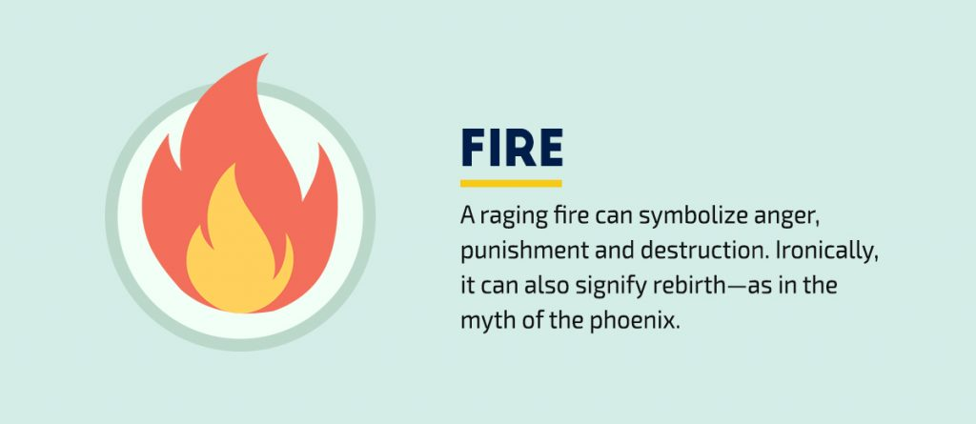
As a crucial element in the development of civilization in the history of mankind, fire is widely seen as a symbol with multiple meanings: a flame can signify wisdom and knowledge, while a raging fire is often used to symbolize fear, pain, anger, punishment, destruction and even death. Such associations likely hearken back to earliest days of mankind.
After all, before humans found ways to properly harness this element, fire was a force that quickly could demolish early settlements. Therefore, fire commanded fear. Still today, drought-ridden regions are consumed by fires that can’t be adequately controlled. Even now, we witness the struggle in the western United States.
On the other hand, fire can also represent rebirth and renewal, as in the example of the phoenix, a mythical bird that ignites itself and emerges from its own ashes. It can also symbolize passion combusting from within.
A caveat to those who are thinking of using the symbol in any type of content: Keep in mind the context when crafting your visual message. For example, while a candle flame may be seen as representative of knowledge, a raging fire may be interpreted as destruction, judgment and danger. Poking smoldering coals to reignite a flame, on the other hand, more accurately describes an igniting passion or lust from within the soul.

9 Arrows
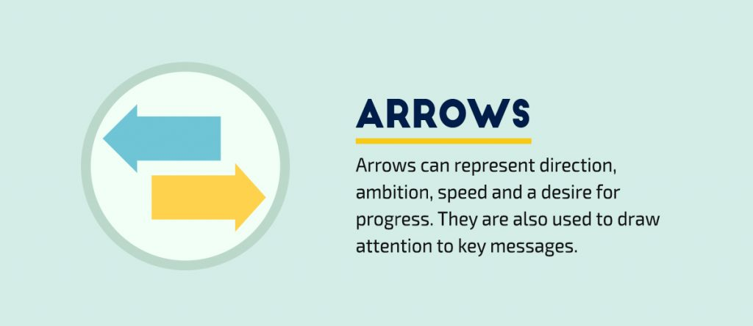
This symbol may bring to mind bows and arrows, like the kind used by Robin Hood and his merry men, but they are also ubiquitous in the modern world: Think of the cursor on your screen or the arrows you see on websites to draw attention to certain elements on the screen. You also see them on highways, where they serve to direct your gaze and steer you in the right direction.
In logos, arrows often signify movement, progress, ambition and direction. Arrows can even be used as a symbol that only our subconscious minds immediately recognize. Examine the famous FedEx logo, for example. Hidden in the white space between the E and the X is an arrow pointing to the right. Since we read from left to right, pointing right signifies moving forward, and the arrow is speed.
RELATED: The Meaning of Shapes and How to Use Them Creatively in Your Designs

10 Flags
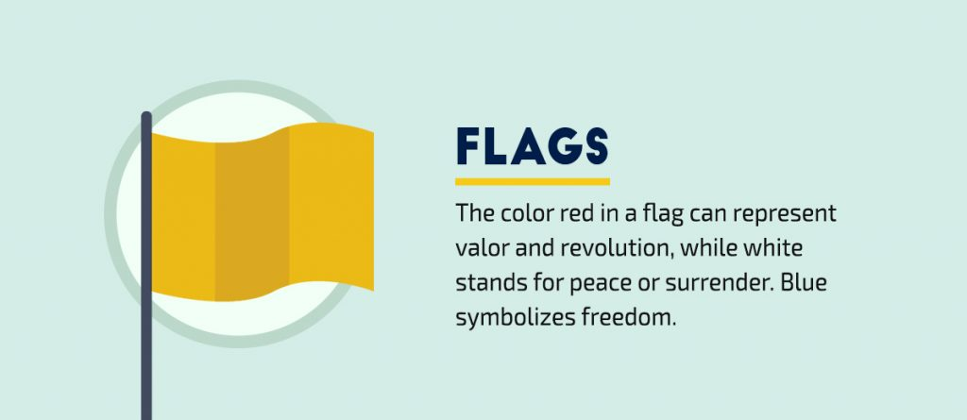
Flags can carry a variety of meanings, depending on the context, symbols and colors used. For example, the rainbow flag is commonly associated with the LGBT movement. Meanwhile, national flags are commonly used to evoke a sense of pride and patriotism in citizens.
The colors used in a banner can symbolize all sorts of concepts, which is why most countries have designed their own flag with the meanings of colors in mind. For example, red can represent blood loss, valor and revolution, while white usually stands for nonviolence and harmony. Blue, on the other hand, symbolizes freedom, yellow stands for wealth and green commonly represents agriculture and fertility. It’s no coincidence then that the most common color combinations on country flags are blue, red and white; and yellow, red and green.
Based on an audience’s country of origin, it will interpret the colors of its national flag as a symbol of patriotism. In the United States, for example, the colors red, white and blue are a symbol of national pride. An Italian audience, however, would react similarly to red, green and white.

11 Rain/Storms
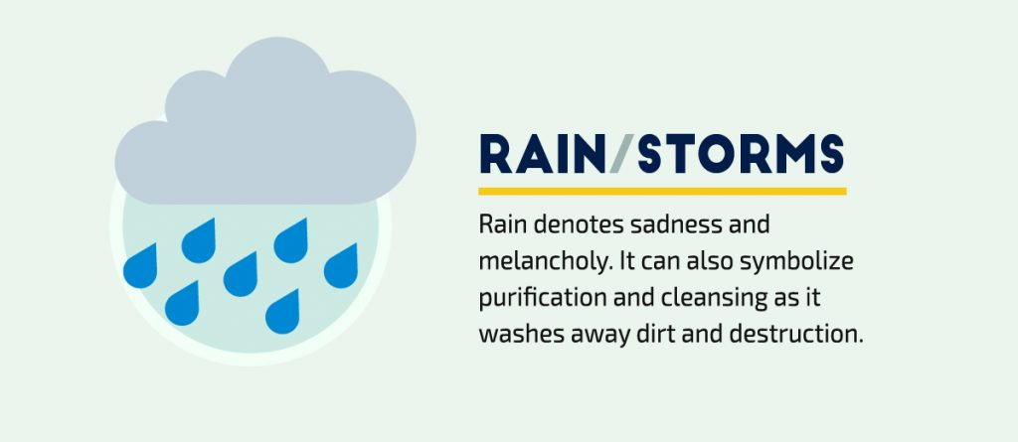
Rain is usually associated with sadness and depression. It’s easy to understand why: Gloomy weather often produces feelings of dreariness, loneliness and pessimism. Consider rain’s role in Dickens’ “A Tale of Two Cities.” Anytime an eventful scene occurs, it just happens to be storming. The rain tells the reader that trouble is approaching.
And although it most commonly denotes sadness and melancholy, the potential of rain’s symbolism is far from limited. In movies, rain has been used to create a sense of fearful apprehension and even represent a person crying.
Rain can also symbolize purification as it washes away dirt and destruction. It can even symbolize the cleansing of the human soul. Just imagine a character walking through a rainstorm as he or she undergoes a mental transformation.

12 Peace sign
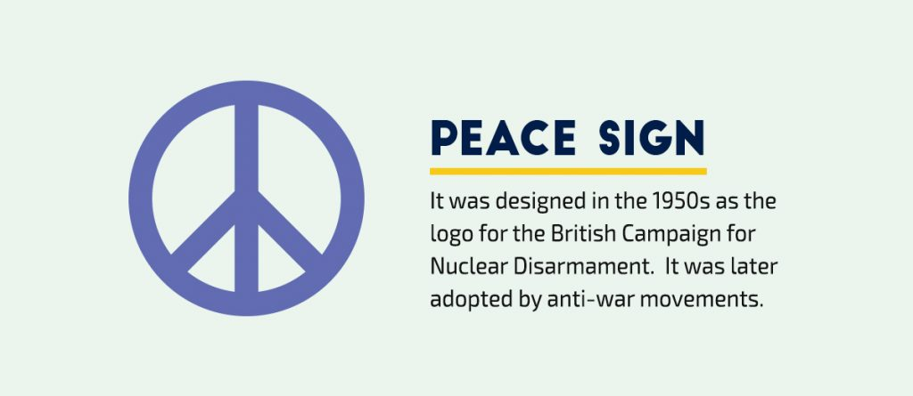
While a variety of peace symbols, such as the dove and the olive branch, have been used in an assortment of ways across cultures and contexts, the "peace sign", we know today was designed in the 1950s as the logo for the British Campaign for Nuclear Disarmament.
A combination of the semaphore signals for the letters "N" and "D", standing for "nuclear disarmament,” the peace symbol was later adopted by a variety of anti-war movements.
Although the symbol instantly brings to mind the hippie movement of the 1960s, it returned to its roots in the 1980s with its adoption as the symbol of the anti-nuclear movement.

13 Occult symbols
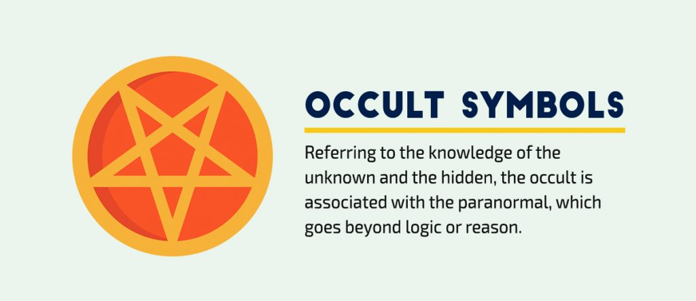
Meaning “unknown” or “hidden,” the occult refers to supernatural phenomena and the paranormal; in essence, all that transcends the limits of human reason. Religions such as Wiccanism and NeoPaganism consider occultism as fundamental to a spiritual experience.
Occult symbols can range from those used in witchcraft and satanism to Kabbalah and other mystical ideologies.
Common symbols such as an inverted pentagram, ankh and the all-seeing eye play an important role in ceremonies and ritual.

14 Hearts
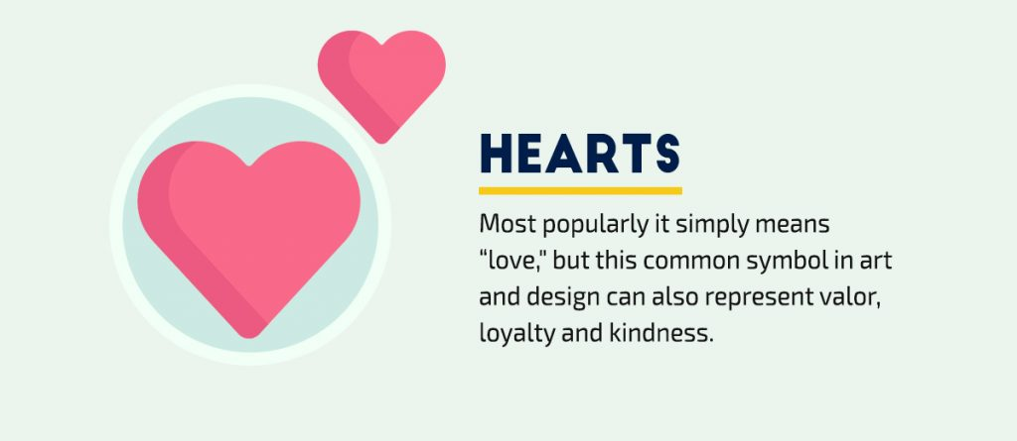
One of the most widely recognized symbols is the heart. While it still means “love,” it can carry much more subtle meanings, and it has many variants that have evolved through time. For example, some of the early versions of the symbols were more realistic and rounded, while newer representations are simplified renditions in the form of pictograms.
The first known use of the heart symbol is found in a 13th-century miniature representing a suitor offering his heart to the woman he is courting. The heart symbol also has been a common feature on coats of arms. In such uses, the symbol can stand for many of the ideas we associate with hearts today, including love, valor, loyalty and kindness. Hearts can also carry a religious connotation, such as when they’re depicted surrounded by flames or thorns.

15 Colors
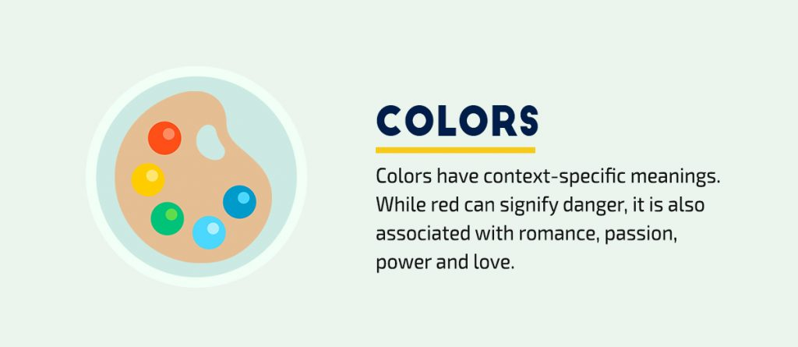
Just like symbols, colors have also been assigned meanings, depending on the context.
Blue, for example, may symbolize disparate ideas, such as calmness and melancholy, at the same time. Another example is the color red. While it is often used to signify danger, it is also frequently associated with romance and love.
Color symbolism can vary greatly because meanings are assigned to different symbols and colors at an individual, cultural and international level.
Marketers can gain a better understanding of how to correctly leverage color symbolism by understanding their context-specific meanings.

16 Skulls
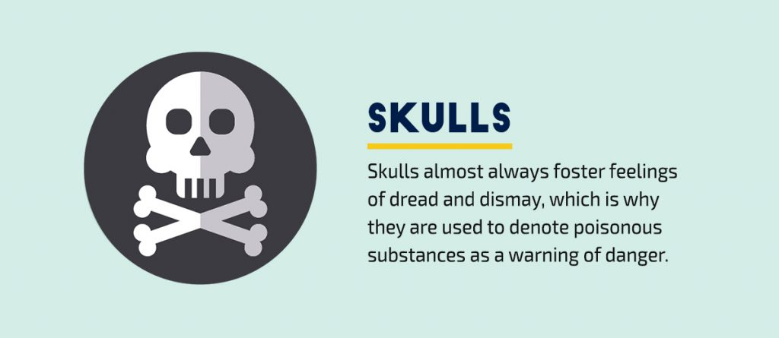
Whenever we see the skull and bones symbol, a few things come to mind: warning labels on poisonous substances, pirate ships, Halloween, death and mortality.
In fact, skulls are the most identifiable bone in the human body, but almost always foster feelings of dread and dismay. After all, any time we see a skull, it means its owner has died.
Graphics featuring a pair of bones crossing below human skull have symbolized death since the Middle Ages. The symbol was engraved on the head of the earliest tombstones in Boston and the rest of New England, and skulls are also the primary symbol of Mexico’s annual Day of the Dead.
As with other symbols, context is key. The popularity of the symbol in modern culture has some fearing that children enthralled by piratery imagery might be attracted instead of repelled by warning labels incorporating the symbol.

Want to communicate visually with symbols?
- Access over 6,000 vector icons
- Edit colors and adjust the size
- Use them in your presentations, printables, social graphics and any other type of visual content.

17 Crescent
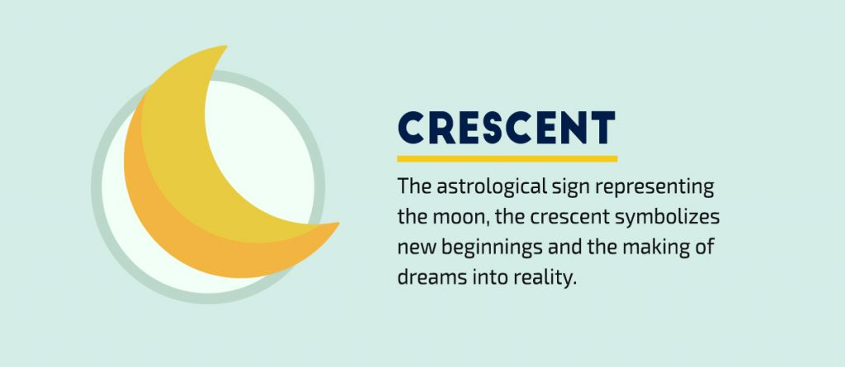
Just as the cross is associated with Christianity and the star of David is a universal symbol of Judaism, a crescent symbolizes another major world religion. But the use of the crescent moon as a symbol predates Islam by several thousand years. In fact, the symbol was in use by ancient cultures in Central Asia and Siberia in their worship of the sun, moon and sky gods.
Because it’s literally a drawing of the second lunar phase, the crescent, also referred to as the sickle, is the astrological sign representing the moon. Since the crescent moon literally means to grow and increase, the shape often symbolizes new beginnings and the making of dreams into reality. It can even be connected to rebirth and immortality.

18 Stars
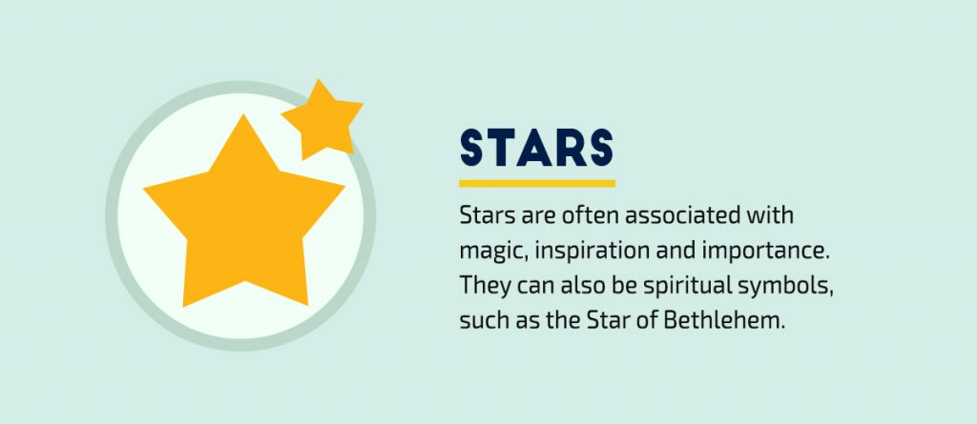
An ancient symbol with many uses, the star can take on different meaning based on both its context and its number of points. Because they are some of the most distant bodies we can see with the naked eye, stars can symbolize physical distance, such as a journey, or emotional distance, such as a misunderstanding.
Before advancements in science were made that allowed humans to understand the nature of our galaxy and its celestial bodies, stars were seen as a symbol of the struggle between light and darkness, between the spiritual and material worlds.
Stars are also commonly associated with magic. Thus, wizards and magicians are often seen with stars on their clothes, and the act of magic can be visually depicted with stars and starbursts. A shooting star is associated with wishes, hope and dreams.

19 Light
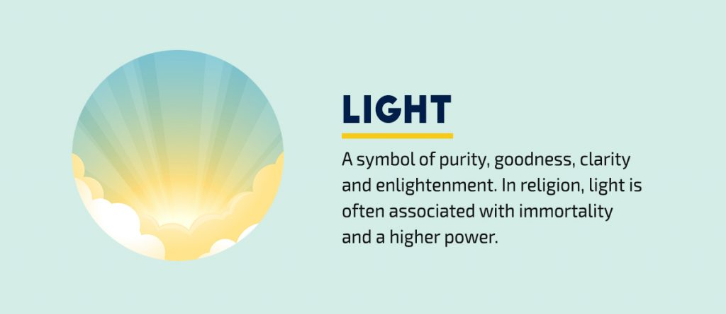
Light is used by many cultures to symbolize illumination in the metaphoric state. It can symbolize purity, goodness, clarity, insight and knowledge.
Light is the symbol of joy and of life-giving power, as darkness is of death and destruction. Therefore, in religion, light is often associated with immortality and a higher power. For example, in the Jewish Holy of Holies, a cloud of light symbolized of the presence of Yahweh.
In our physical world we see things through the medium of light. In the symbolic world, we see not with light but with wisdom. Therefore, light is often associated with enlightenment.

20 Darkness
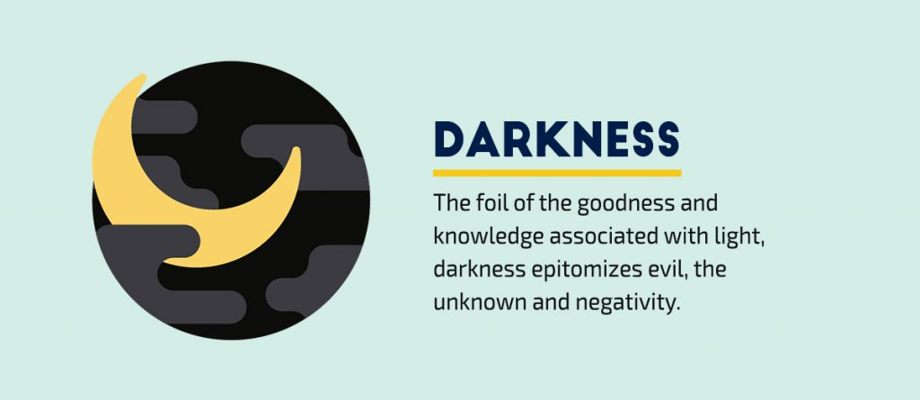
The foil of the goodness and knowledge associated with light, darkness epitomizes evil, the unknown and negativity. Just as yin is to yang, darkness and light represent two opposing forces of nature, whether good and evil, knowledge and ignorance, love and hate or happiness and despair.
Therefore, visual storytellers can use this symbol to represent any of the following: death or the transition to the afterlife; the lack of a clear vision; the evils and mysteries of the night; the darkness of the human soul.

Bonus Visual Symbols and Meanings

21 Lion
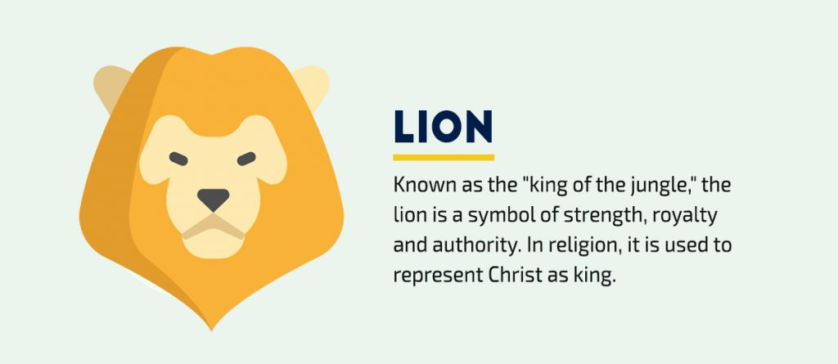
Known as the "king of the jungle," the lion is a symbol of strength, royalty and authority. In religion, it is used to represent Christ as king.

22 Swan
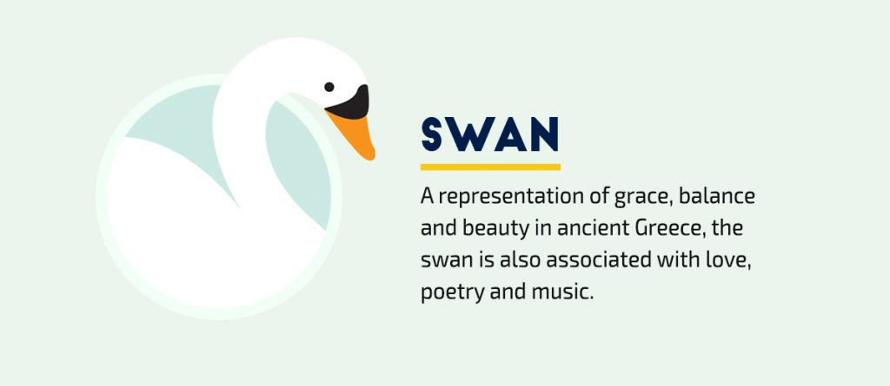
A representation of grace, balance and beauty in ancient Greece, the swan is also associated with love, poetry and music.

23 Spider
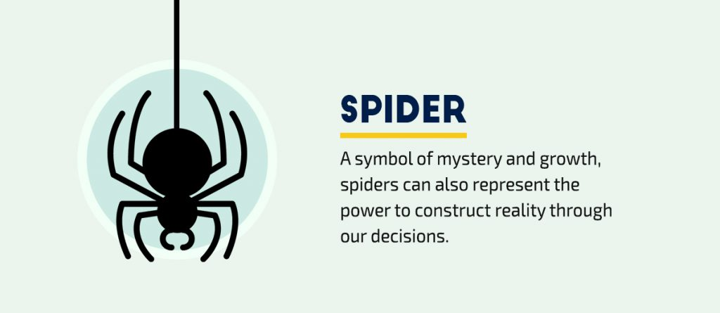
A symbol of mystery and growth, spiders can also represent the power to construct reality through our decisions.

24 Wolf
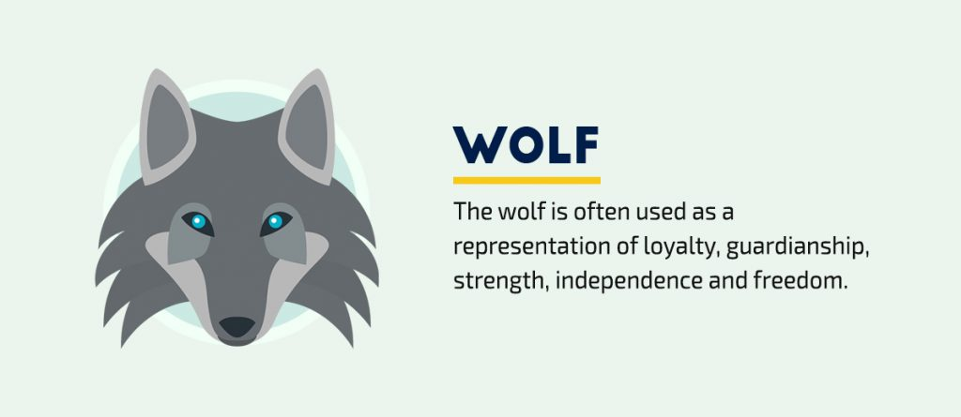
The wolf is often used as a representation of loyalty, guardianship, strength, independence and freedom.

25 Viking
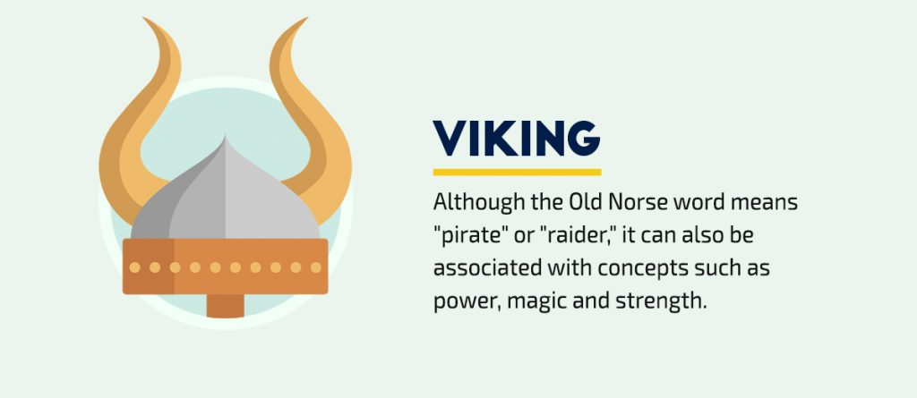
Although the Old Norse word means "pirate" or "raider," it can also be associated with concepts such as power, magic and strength.

26 Phoenix
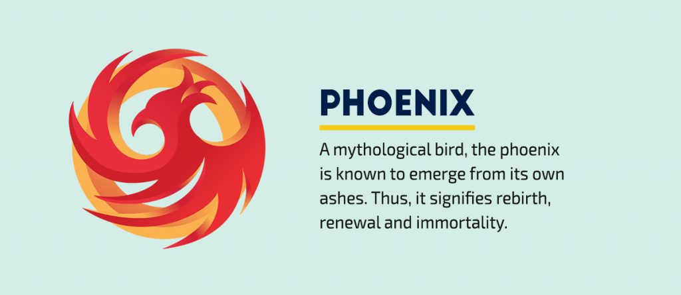
A mythological bird, the phoenix is known to emerge from its own ashes. Thus, it signifies rebirth, renewal and immortality.

27 Triangle
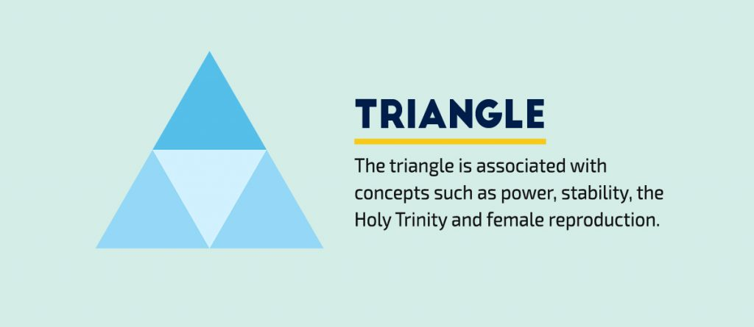
The triangle is associated with concepts such as power, stability, the Holy Trinity and female reproduction.

28 Rainbow
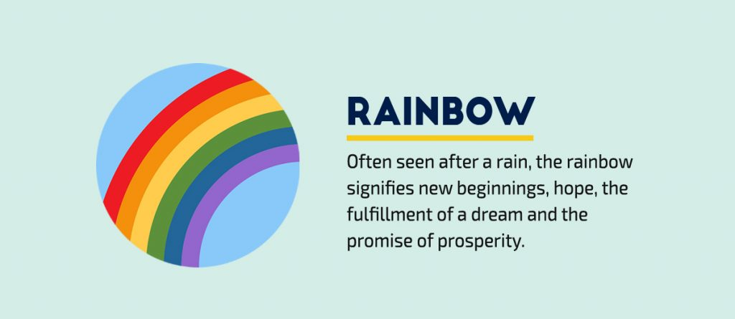
Often seen after a rain, the rainbow signifies new beginnings, hope, the fulfillment of a dream and the promise of prosperity.

Want to use symbols in your own visuals?
- Access over 6,000 vector icons
- Edit colors and adjust the size
- Use them in your presentations, printables, social graphics and any other type of visual content.

29 Circles
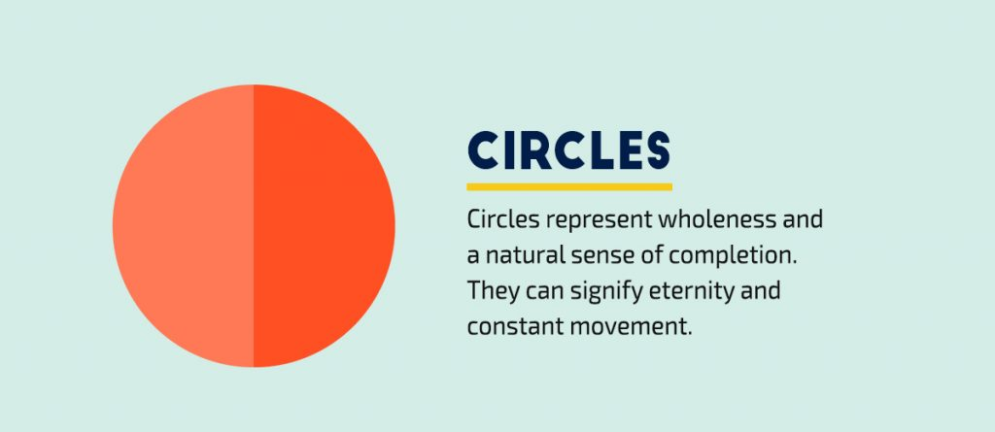
Circles represent wholeness and a natural sense of completion. They can signify eternity and constant movement.

30 Dragon
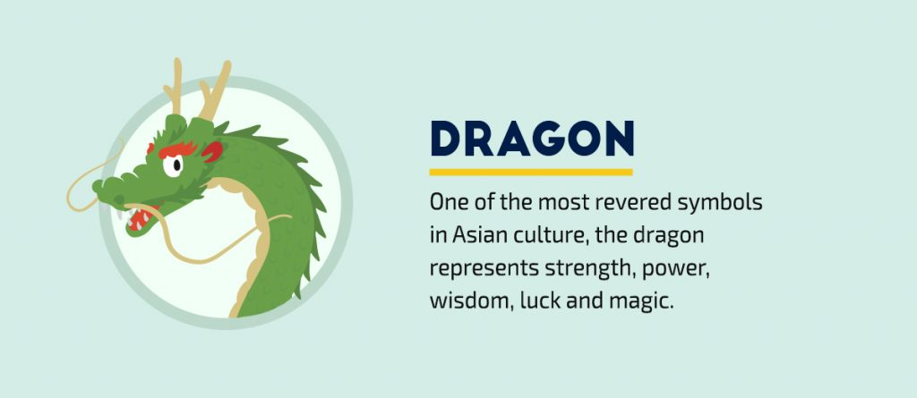
One of the most revered symbols in Asian culture, the dragon represents strength, power, wisdom, luck and magic.

31 Angels
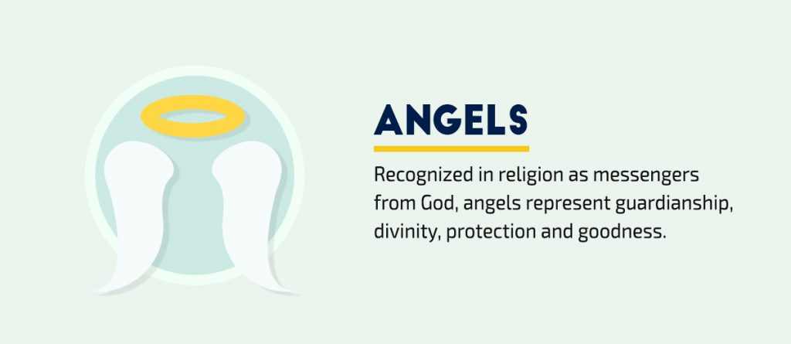
Recognized in religion as messengers from God, angels represent guardianship, divinity, protection and goodness.

32 Demons
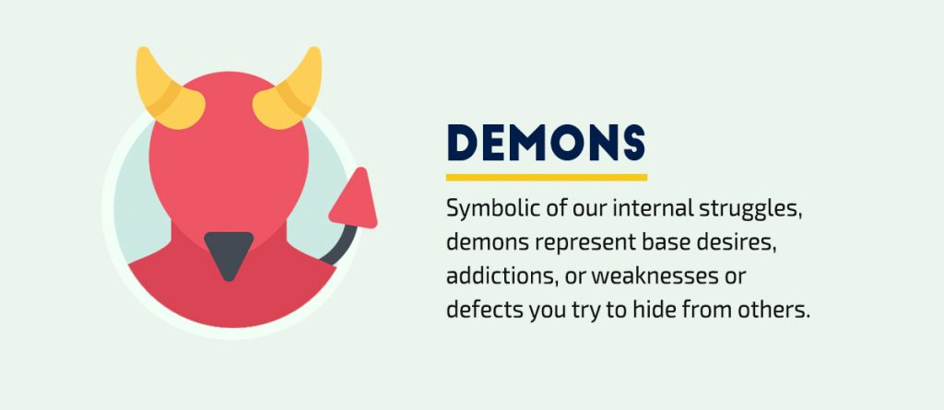
Symbolic of our internal struggles, demons represent base desires, addictions, or weaknesses or defects you try to hide from others.

33 Peacock
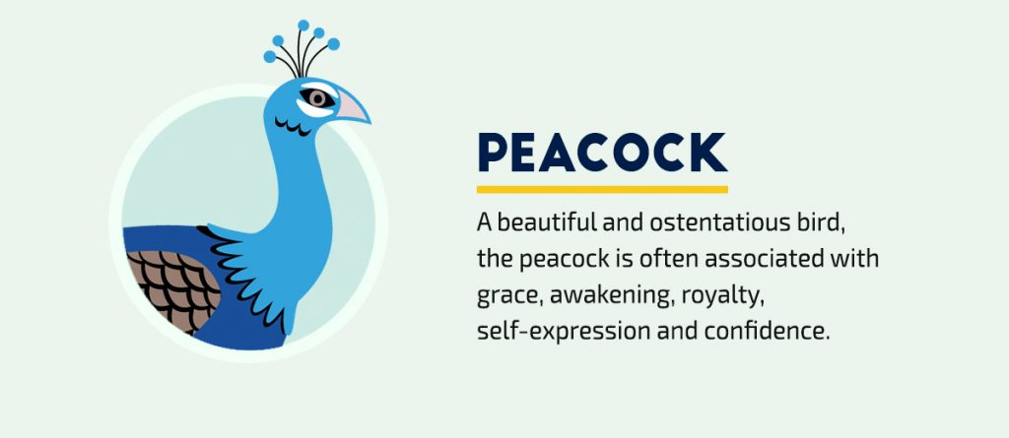
A beautiful and ostentatious bird, the peacock is often associated with grace, awakening, royalty, self-expression and confidence.

34 Eggs
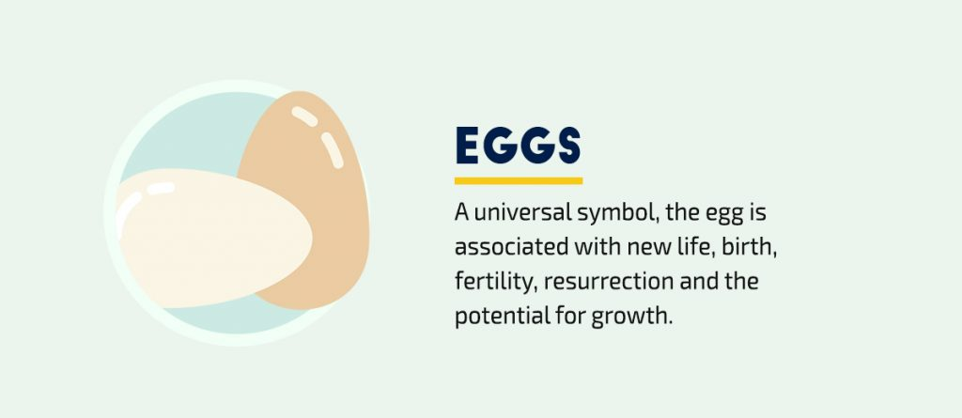
A universal symbol, the egg is associated with new life, birth, fertility, resurrection and the potential for growth.

35 Witches
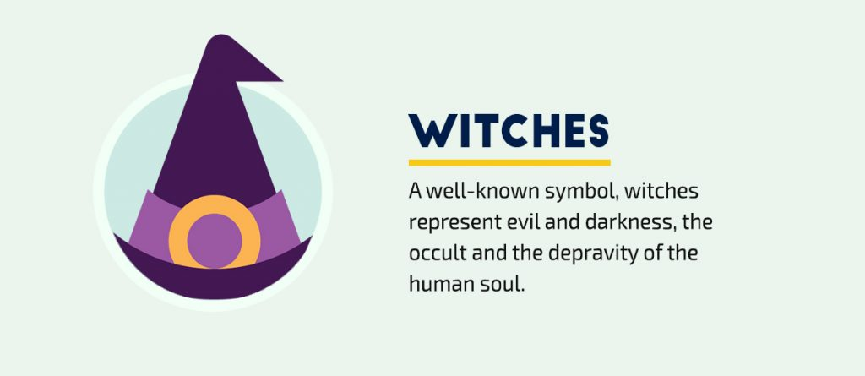
A well-known symbol, witches represent evil and darkness, the occult and the depravity of the human soul.

36 Rabbits
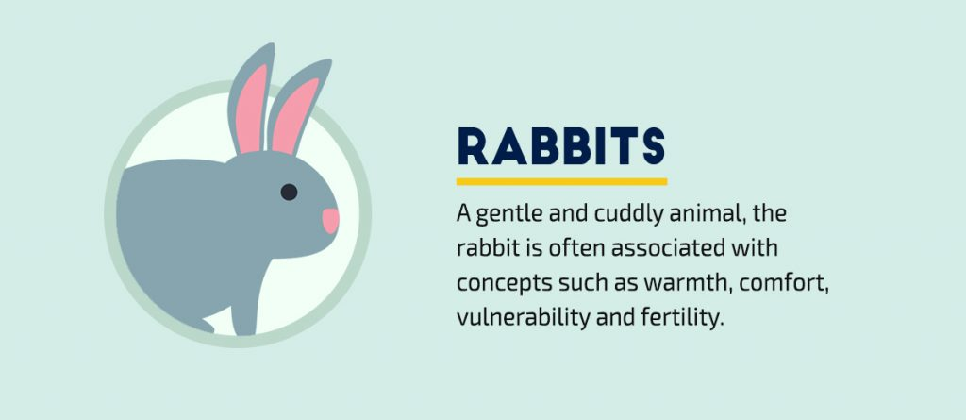
A gentle and cuddly animal, the rabbit is often associated with concepts such as warmth, comfort, vulnerability and fertility.

37 Trees and forests
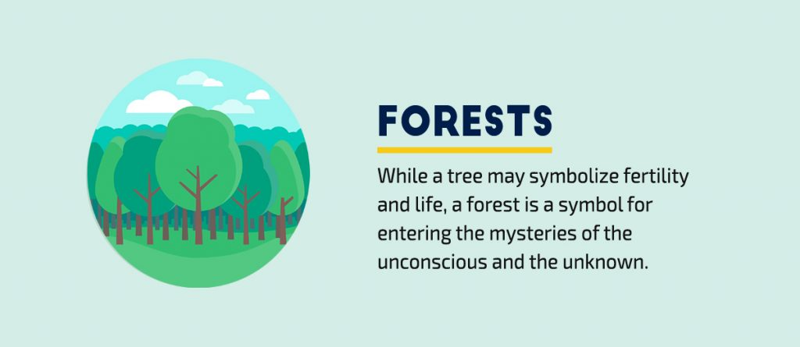
While a tree may symbolize fertility and life, a forest is a symbol for entering the mysteries of the unconscious and the unknown.

38 Planets
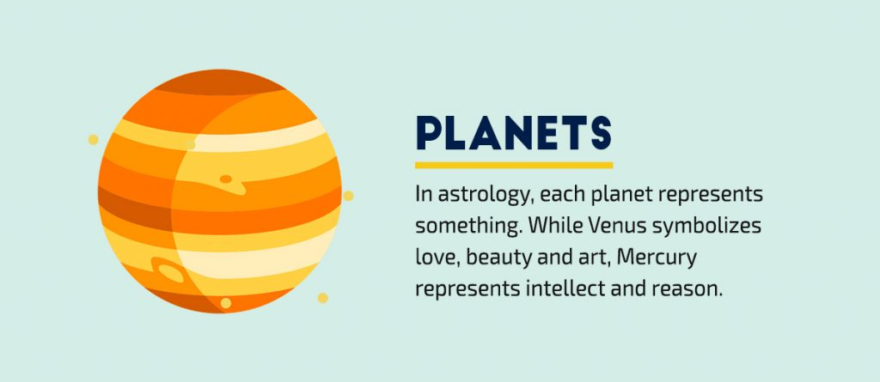
In astrology, each planet represents something. While Venus symbolizes love, beauty and art, Mercury represents intellect and reason.

39 Sun
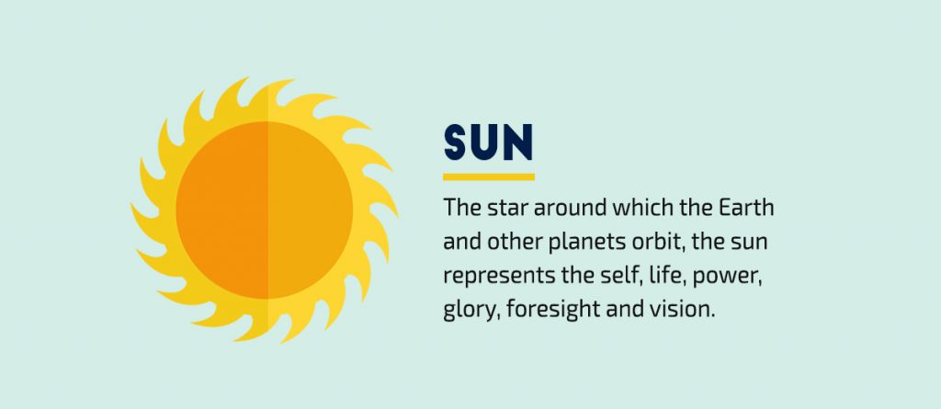
The star around which the Earth and other planets orbit, the sun represents the self, life, power, glory, foresight and vision.

40 Moon
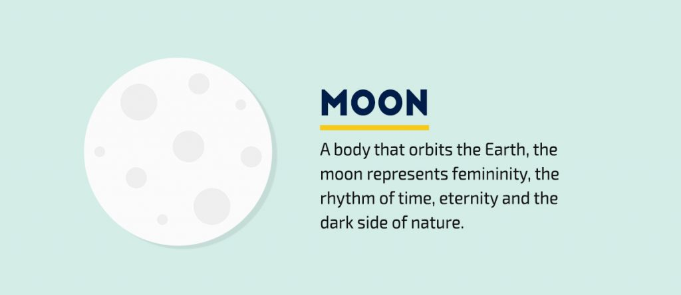
A body that orbits the Earth, the moon represents femininity, the rhythm of time, eternity and the dark side of nature.

Your Turn
Were any of the above symbolic meanings a surprise? Which symbol have you most often used in your visual designs

